Casino Game : Propsal

Members: Ohad Badhav, Elizaveta Sidorova, Snir Ben Nissim

1. The Casino game is a multiplayer game, in which you can create your own room, or join an existing one, to play together in our casino games.
2. The added benefit of our project is based on playing with your nearby friends quickly, through our location detection. This unique option allows you to play without the need to add them to your friend list, only being around them.
3. While some multiplayer casino games exist, many lack the ability for players to join rooms with their nearby friends. In other words, while they may facilitate multiplayer interactions, they often overlook the opportunity for players to easily connect with friends in their vicinity. This limitation can detract from the social aspect of the gaming experience, as players may prefer to engage in casino games with familiar faces or acquaintances nearby. By incorporating a feature that allows players to join their nearby friends' rooms, our game enhances the social dimension of the casino experience. This addition distinguishes our game from others in the genre, providing a more immersive and enjoyable multiplayer experience.
4. Our expected users are groups of people, who like the casino games, and would like to play together.

In addition, the users are also single players who are nearby other players, which can gather and play together.

The main screen of the game is the creating and joining rooms.

In case of creating a room, you will see a screen where you pick the game (Poker, Blackjack, and more).

In case you join a room, you will see a list of optional rooms.

After asking to join a room, the creator of the room will see a notification of the player’s Avatar, name, and balance. Now the creator of the room have the option to accept the request or deny it.

The opening application screen will be the login/sign-in screen.

The creator of the room has the option to stream the game on a different screen that shows the relevant features for all the players. Each mobile device will show the individual player’s features.

1. Our game boasts a diverse selection of casino games including Poker, Blackjack, Wheel of Fortune, and Horse Racing. Using our location detection feature, players can swiftly join games with their nearby friends, providing an authentic casino experience as they play alongside others at the same table/ same screen.

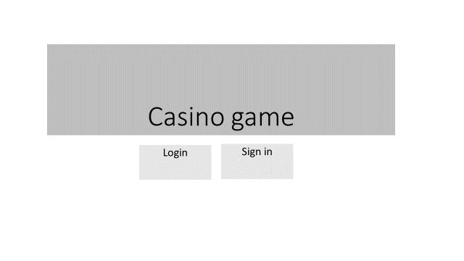Top of Form

